KS4 Geography Project – May Half Term 2020 – Cyclone Amphan
As part of your Geography GCSE, you have studied tropical storms when we looked at natural hazards. This is an opportunity to apply your knowledge and understanding of tropical storms to a live news story as it unfolds.
At the time of writing, Cyclone Amphan is building in strength in the Bay of Bengal and is predicted to make landfall close to the border between India and Bangladesh on Wednesday 20th May. These countries are trying to prepare/evacuate millions of coastal residents. To make matters worse, all this is taking place during a lockdown to try to stop coronavirus spreading through these countries (https://www.bbc.co.uk/news/world-asia-india-52718826).
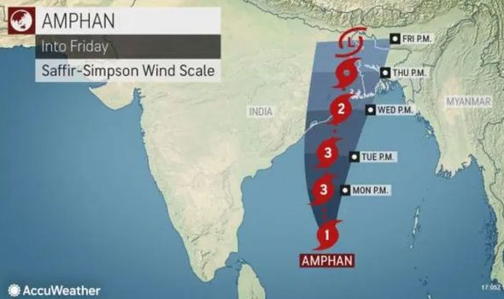

Your project is to follow this news story in the media as it develops and, on a separate piece of paper, construct a timeline of events covering the causes, effects and response to Cyclone Amphan (you may wish to colour code these).

Challenge – What makes this part of the world particularly vulnerable to tropical storms? Consider both human and physical factors.
________________________________________________________________________________________________________________________________________________________________________________________________________________________________________________________________________________________________________________________________________________________________________________________________________________________________________________________________________________________________________________________________________________________________________________________________________________________________________________________________________________

